**PROJECT REPORT ON PIPING DETAIL ENGINEERING**



PROJECT DONE BY

SHAIK NAZEER BASHA

Roll No : 17481A0393

**PIPING DETAIL ENGINEERING FOR RIVER WATER TREATMENT PLANT**

**TABLE OF CONTENTS:**

1. TYPES OF PROCESS PLANTS
2. MAJOR PLAYERS IN THE PROJECT- OWNER, EPC CONTRACTOR, ENGINEERING CONSULTANT
3. PHASES IN ENGINEERING
4. ROLE OF MECHANICAL ENGINEERING IN PROCESS INDUSTRY
5. LIST OF DOCUMENTS PREPARED FOR MECH/PIPING DETAIL ENGINEERING
6. MECHANICAL ENGINEERING INPUTS AND INTERFACE REQUIREMENTS
7. PIPING AND INSTRUMENTATION DIAGRAM
8. DIFFERENT LAYOUTS AND ITS USE
9. PIPE LINE SIZING CALCULATION
10. PIPE THICKNESS CALCULATION
11. PIPE PRESSURE DROP CALCULATIONS
12. LINE LIST
13. PIPE FITTINGS AND COMPONENTS
14. PIPE SUPPORTS

# TYPES OF PROCESS INDUSTRIES

# 

An industry/plant which processes the raw products into the semi-finished or finished end product by defining the stage by stage process, utilities required for operation, and also control and operation procedure based on the customer requirement is called processing industry.

For the design of any process industry various disciplines like Chemical, Civil& structural, Mechanical, Piping, Electrical, Control & Instrumentation need to be involved for the start of the process to achieve the required output.

Major process industries are

1. Oil & gas (Offshore & Onshore)
2. Power (Thermal/ Hydroelectric/ Solar/Nuclear)
3. Petrochemical
4. Pharmaceutical
5. Fertilizer
6. Chemical

# MAJOR PLAYERS IN THE PROJECT

To build and operate the plant we require different parties/ contractors for performing different activities in each phase of the project.

The important players in the industry are

**OWNER/CLIENT/END-USER**: The one who owns the responsibility to maintain, operate and produce energy. **Example**: IOCL, NTPC, RELIANCE, HPCL.

* **EPC contractor:** The company which helps the Owner in giving Engineering, Procurement and Construction services to build the process plant and sets to operation of the plant. Once the plant is run/operated, then the complete operation of the plant will be handed over to Owner.

**Example**: L&T, TATA PROJECTS, JGC.

**Engineering Consultant:** The company who does the complete design and detail engineering i.e. defines the technical requirements

**Example:**  Honeywell, Hitachi.

# PHASES IN ENGINEERING

1. **Front End Engineering Design (FEED):**

It is to define the technical and project specific requirements for a system to provide a clear scope and design basis for entrance into execution phases. The secondary goal of FEED is to develop a good project cost estimate that can be used further for budget authorization

The following documents shall be prepared in Basic/ FEED engineering

* Project/ Job specification
* Plant site-data
* Preliminary Plot Plan
* Preliminary Piping & Instrument diagrams
* Technical specifications

1. **Pre-bid Engineering:**

It is the phase where visions and plans become reality. This phase of engineering is done for evaluating the total project cost by estimating the material required and also manpower required for executing the project within the timeline defined by the Customer. The quantities and cost of the project will be submitted in the form of bid document and will participate in the bidding process to be preferred consultant to execute the project (L1 bidder). Inputs for carrying out pre-bid engineering activity will be FEED engineering documents.

The following documents shall be prepared in Pre-bid Engineering includes:

* Review of P&IDs and scope of work
* Technical clarifications/queries for any missing information or ambiguities
* Material take-off (MTO) / Bill of material (BOM)
* Material requisitions to float enquiry to Vendors for cost of particular item/ equipment
* Basis of Proposal (This document specifies any assumptions, deviations, exclusions with reference to scope of work)
* Man-hour estimation (This gives the detail engineering duration of the project, time required for each document we prepare in detail engineering, software requirement and also team members in the project)

**TOTAL PROJECT COST = MATERIAL COST + ENGINEERING COST + MAN -POWER COST**

1. **Detailed Engineering:**

It is the phase to develop all the design drawings and documents. This engineering information is used for purchase/procurement of the material, defining fabrication and installation of the system. All engineering disciplines required for the project are included in this phase.

**Piping detail engineering activities:**

* Pipe design – Line sizing details
* Pipe material selection
* Pipe stress analysis
* Pipe routing and clash resolution (2D or 3D Modelling)
* Pipe support details
* Piping Isometrics.

**Mechanical detail engineering activities**

* Vessel and Reactor Design.
* Exchanger Thermal Design.
* Equipment Selection and Specification.
* Rotating Equipment Selection.

# ROLE OF MECHANICAL ENGINEERING IN PROCESS INDUSTRY:

Mechanical engineer plays an important role in Mechanical Equipment design and Piping design.

However, the complete engineering is divided into detail engineering and design engineering.

**Engineer (Detail engineering) –** One who involves in preparation of technical specifications, Datasheets, Design calculations, MTO and review of vendor technical information as procurement support activity.

**Designer (Design engineering) –** The one who prepares pipe routing drawings, Location layouts, Plot plan etc. (i.e. who does the modelling part either 2D or 3D)

**Draftsmen-** The one who updates the drawings based on the inputs/writeup provided by the Engineer/Designer. Drafting activities based on the red mark-ups/ comments from Client/ Engineer/Designer. Works on either AutoCAD or any designing 3D Modelling tool.

**Project Engineer/Manager –** The one who involved in complete scope of work for a project and different interfacing requirement with another disciplines/ Client/ Vendor. He also prepares the plan for the execution of the project. Project plan includes, master deliverables list & complete project activities with submission timelines.

**Site Engineer –** The one who takes care of the repairs and maintenance activities of the equipment/ pipe at site**,** fixing the issues that arises and also ensures that regular checks are done to avoid any failure or malfunctioning of the equipment.

# LIST OF DOCUMENTS PREPARED FOR MECHANICAL/PIPING

# **DETAIL ENGINEERING PHASE:**

**MECHANICAL DETAIL ENGINEERING DOCUMENTS:**

▪ Mechanical Equipment Design Criteria

▪ Equipment List

▪ Specifications

▪ Datasheets

▪ Equipment General Arrangement Drawing

▪ Equipment Pressure Vessels Calculations

▪ Equipment Spare Part Details

▪ Material Take-Off

▪ HVAC Design

▪ Mechanical Package Design and Interface Engineering

**PIPING DETAIL ENGINEERING DOCUMENTS**:

▪ Overall Site Plot Plan

▪ Process Area Plot Plans

▪ Piping & Instrumentation Diagrams

▪ Line List and Valve List

▪ Piping Material Specifications

▪ Special Piping (SP) Item Schedule and Data Sheets

▪ Standard Piping Details

▪ Fabrication and Installation of Pipe-Work Specification

▪ Piping General Arrangement Drawings

▪ Isometric Drawings for 2" And Above Pipe-Work Above and Below Ground

▪ Material Take-Offs

▪ Key Plans Of Piping General Arrangements.

▪ Stress Analysis Specification and Stress Report

▪ Pipe Routing Drawing above Ground and Below Ground

# MECHANICAL ENGINEERING INPUTS AND INTERFACE REQUIREMENTS:

**INPUTS REQUIRED ARE:**

* Project specification
* Plant process description
* Process flow diagram (PFD)
* Fluid list with its process parameters and properties
* Heat and mass balance drawing
* Water balance drawing
* Tie-in point details

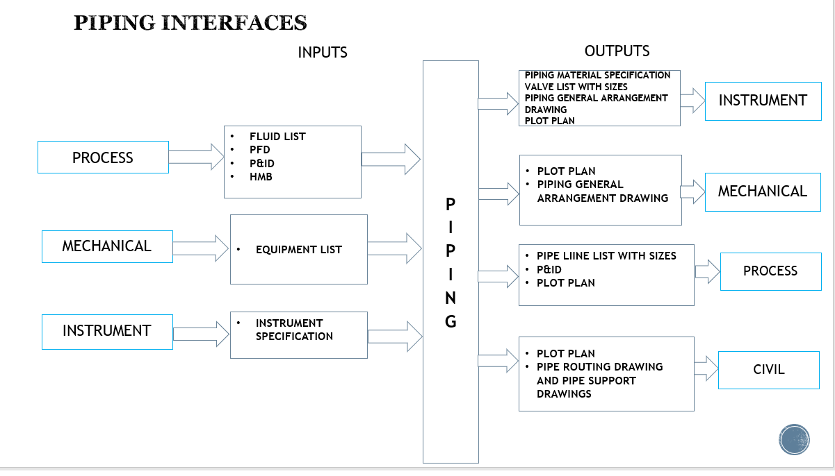

**MECHNICAL INTERFACE WITH OTHER DISCIPLINES:**

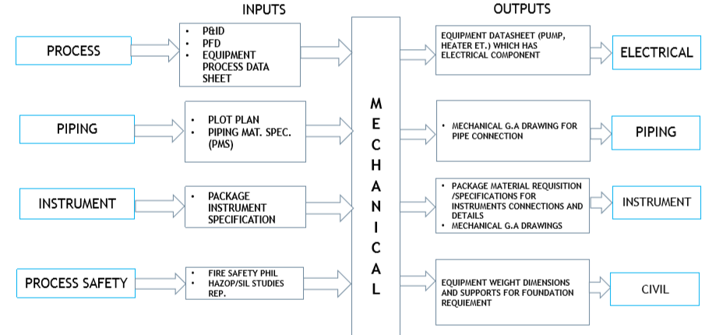

**PIPING INTERFACE WITH OTHER DISCIPLINES:**

**7. PIPING AND INSTRUMENTATION DIAGRAM :**

* Definition of P&ID :

This drawing shows the details about the process flow and interconnection of process equipment to control the process.

* Preparation of P&ID:

Process engineer or Mechanical (Piping engineer) is the owner of the drawing and will be circulated to other disciplines i.e. Instrumentation, mechanical(equipment engineer), Electrical engineer for including specific discipline details in the drawing.

* P&ID process discipline details are :
* Type of process fluid
* Direction of flow of the process fluid –
* Drawing connectivity based on the process flow diagram
* Process parameters of the fluid i.e. pressure, temperature and flow
* Required operational controls for plant safety operation
* Interlock philosophy and equipment safe start pre-requisites
* Redundancy requirements based on the process criticality
* No. of Train requirements based on the project process specification to meet the desired output
* Piping discipline details: Insulation type, sequence number, prefix or suffix.
* Pipe tag number specifying the line size, area/unit code, fluid type, pipe class (pipe m
* Manual valves (Gate, globe, check, ball, NRV).
* Pipe nozzle connection (flanged or welded or threaded) for the instrument connections.
* Mechanical discipline details:

* Equipment description (pumps, tanks, vessels, drums, compressors, mixers, stirrer etc.)
* Equipment tag number.
* Equipment capacity.
* Nozzle size details for connection to pipe and instruments.
* Insulation requirement.
* Instrumentation discipline details:
* Process measuring instruments i.e. Pressure, temperature, flow and level transmitters and gauges.
* Automatic control valves .
* Inputs required for preparing P&ID for Piping/Mechanical engineer:
* Project specification .
* Plant process description.
* Process flow diagram (PFD) .
* Fluid list with its process parameters and properties.
* Heat and mass balance drawing.
* Water balance drawing.
* Tie-in point details.

The P&ID of our project is given here in attachment: [DIESEL FUEL SYSTEM P&ID](https://d.docs.live.net/fce45fd41e52f98e/Desktop/P%5e0ID%20internship/PROJECT/DIESEL%20FUEL%20SYSTEM%20%20P%5e0ID.dwg)

1. **DIFFERENT LAYOUTS AND ITS USE:**

* **Definition of Piping layout:**

A layout shows the overall dimensions 0f plants/ system from where the plant starts and ends which shows all the piping, equipment nozzles, structure, piping supports etc.

* **Piping layout guidelines:**
* Arrange piping to allow full access to equipment for operation and maintenance.
* Ensure that equipment can be removed without also removing block valves and large sections of piping.
* Avoid long, straight runs of pipe between two anchor points,such as two pieces of equipment.
* **Uses:**
* By using piping layout the user will be able to visualize the overall relationship of all the piping systems, steel, and equipment.
* It helps the user to recognise the fault easily if it exits in piping.
* **Definition of Equipment layout:**

Equipment layout is the detailing of conceptual layout .......equipment layout consists of following information floor space required needed for the equipment and other facilities are shown and access, removal space, cleaning area, storage space and handling facilities are outlined.

* **Equipment layout guidelines:**
* In practical align the equipment and piping symmetrically to provide an organized appearance.
* Align the equipment and process flow so that this can optimize piping runs and even take the advantage of gravity.
* Take thermal expansion in to account.
* Provide enough space between each piece and equipment to provide appropriate access for operations and maintenance.
* **Uses:**

Good equipment layout helps to ensure that:

* Equipment can be clearly identified.
* Equipment is easy and efficient to use.
* Errors are avoided, especially during emergency conditions.

1. **PIPE LINE SIZING CALCULATION** :

**What is pipe line sizing?**

* The main purpose of line sizing is to fill in appropriate data on P&ID’s, data sheets, and line lists.
* To determine pump head requirements. To meet design process parameters such as flow, velocity, and pressure.

FOR LINE SIZING CALCULATION REFER BELOW ATTACHMENT

[PIPE SIZING CALCULATIONS](https://d.docs.live.net/fce45fd41e52f98e/Desktop/P%5e0ID%20internship/PROJECT/PIPE%20SIZING%20CALCULATIONS.docx)

1. **PIPE THICKNESS CALCULATION:**

This pipe thickness calculation is done to get the required pipe thickness for a process pipe.

* **Inputs required are:**
* Pipe material of construction.
* Pipe construction type; seamless, EFW, ERW etc.
* Design temperature.
* Design pressure.
* Corrosion allowance for material and operating conditions.
* Mechanical allowance.

**Formula to calculate pipe thickness:**

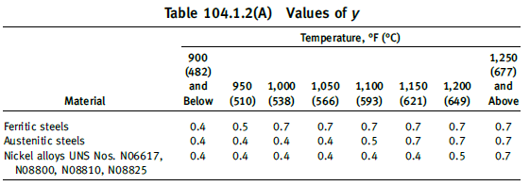

tm=(PD0 /2(SE+Py) ) + A

For pipe with a D0/tm ratio less than 6, the value of y for ferritic and austentic steels designed for temperarures of 9000F (4800C) and below shall be taken as:

1. **PIPE PRESSURE DROP CALCULATIONS:**

* When fluid flows through a pipe there will be a pressure drop that occurs as a result of resistance to flow. This overall pressure difference across the pipe is related to a number of factors :
* Friction between the fluid and wall of the pipe.
* Friction between adjacent layers of the fluid itself.

PRESSURE DROP CALCULATIONS GIVEN IN BELOW ATTACHMENT

[PRESSURE DROP CALCULATION](https://d.docs.live.net/fce45fd41e52f98e/Desktop/P%5e0ID%20internship/PROJECT/PRESSURE%20DROP%20CALCULATION.docx)

1. **LINE LIST:**

* A line list is a data base created to communicate between the process and mechanical engineering terms when designing piping in a plant or process unit.
* As it’s core, it should help to provide justification on why certain decisions were made in the design process.

The line list of our P&ID is given in the below attachment

[DIESEL FUEL SYSTEM LINE LIST.xlsx](DIESEL%20FUEL%20SYSTEM%20LINE%20LIST.xlsx)

[FILTERATION PACKAGE LINE LIST](https://d.docs.live.net/fce45fd41e52f98e/Desktop/P%5e0ID%20internship/PROJECT/FILTERATION%20PACKAGE%20LINE%20LIST.xlsx)

1. **PIPE FITTINGS AND COMPONENTS:**

* **Definition :** A fitting or adapter is used in pipe systems to connect straight sections of pipe or tube, adapt to different sizes or shapes and for other purposes such as regulating fluid flow.

* **Uses:**
* Helps to change the direction of flow.
* Ex: Elbows, tees.
* Changers the size of the pipe such as reducers, reducing tees.
* Connect different components such as couplings and stop the flow such as caps
* **Types of components :**
* Elbows
* 450 Elbow
* 900 Elbow
* 1800  Bends
* Long radius
* Short radius
* Tees
* Equal Tee
* Reducing Tee
* Coupling:
* Full Coupling
* Half Coupling
* Reducing Coupling

Some of the components of fittings are drawn and click on the below to open it :

[80 NB](https://d.docs.live.net/fce45fd41e52f98e/Desktop/P%5e0ID%20internship/PROJECT/80%20NB%20ANSI.dwg)

[BUTT WELDED EQUAL TEE](https://d.docs.live.net/fce45fd41e52f98e/Desktop/P%5e0ID%20internship/PROJECT/BUTT%20WELDED%20EQUAL%20TEE.dwg)

[BUTT WELDED 90 LONG RADIUS](https://d.docs.live.net/fce45fd41e52f98e/Desktop/P%5e0ID%20internship/PROJECT/BUTT%20WELDED%2090%20DEGREES%20LONG%20RADIUS.dwg)

[BUTT WELDED EQUAL TEE AND REDUCING TEE](https://d.docs.live.net/fce45fd41e52f98e/Desktop/P%5e0ID%20internship/PROJECT/BUTT%20WELDED%20EQUAL%20TEE%20AND%20REDUCING%20TEE.dwg)

[SOCKET WELDED REDUCING COUPLING](https://d.docs.live.net/fce45fd41e52f98e/Desktop/P%5e0ID%20internship/PROJECT/SOCKET%20WELDED%20REDUCING%20COUPLING%5e.dwg)

[THREADED 90 ELBOW](https://d.docs.live.net/fce45fd41e52f98e/Desktop/P%5e0ID%20internship/PROJECT/THREADED%2090%20DEGREES%20ELBOW.dwg)

1. **PIPE SUPPORTS:**

**Definition:**

A pipe support or pipe hanger is a designed element that transfer the load from a pipe to the supporting structures. The load includes the weight of the pipe proper, the content that the pipe carries, all the pipe fittings attached to pipe, and the pipe covering such as insulation.

**Uses of having supports:**

* Pipe fittings are used in piping systems to change direction of the liquid flow.
* They are used connect pipes in different sizes.
* They are used to change pipe diameter and branch the liquid flow from one pipe into multiple pipes.

**Types of supports**

**Vibration absorbers:**

To restrict the movement due to vibration caused by wind earthquake, fluid flow.

Types:

* Snubbers.
* Sway brace.
* Hold down.

**Hanger/ support**

To sustain the dead weight of the piping system.

**Types:**

* Rigid hanger
* Spring hanger
* Variable
* Constant
* Shoes
* Trunnions.

**Restraint:**

To restrict the movement due to thermal / dynamic loading.

**Types:**

* Anchor.
* Guide.
* Directional anchor.
* U clamps.
* Struts.